**Unit 2 | Assignment - The VBA of Wall Street**

**Background**

You are well on your way to becoming a programmer and Excel master! In this homework assignment you will use VBA scripting to analyze real stock market data. Depending on your comfort level with VBA, choose your assignment from Easy, Moderate, or Hard below.

**Files**

* [Test Data](http://uci.bootcampcontent.com/UCI-Coding-Bootcamp/UCIRV201801DATA3-Class-Repository-DATA/blob/master/02-Homework/02-VBA-Script/Instructions/Resources/alphabtical_testing.xlsx) - Use this while developing your scripts.
* [Stock Data](http://uci.bootcampcontent.com/UCI-Coding-Bootcamp/UCIRV201801DATA3-Class-Repository-DATA/blob/master/02-Homework/02-VBA-Script/Instructions/Resources/Multiple_year_stock_data.xlsx) - Run your scripts on this data to generate the final homework report.

**Stock market analyst**

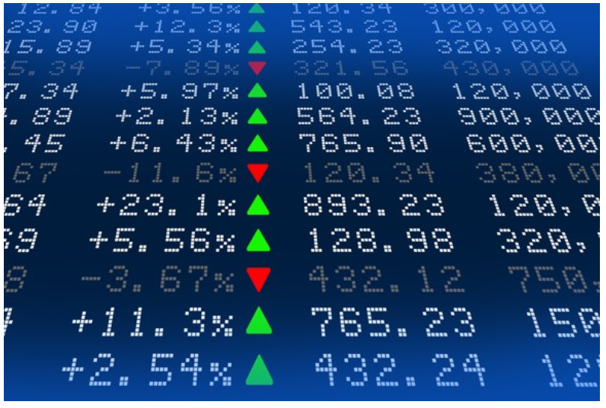

**Easy**

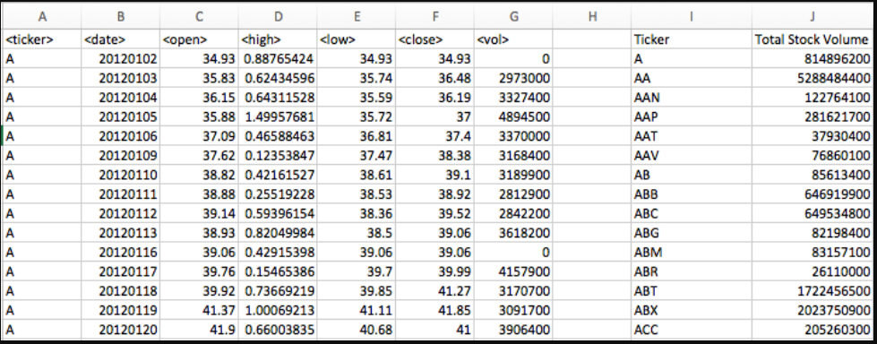

* Create a script that will loop through each year of stock data and grab the total amount of volume each stock had over the year.
* You will also need to display the ticker symbol to coincide with the total volume.
* Your result should look as follows.

**Moderate**

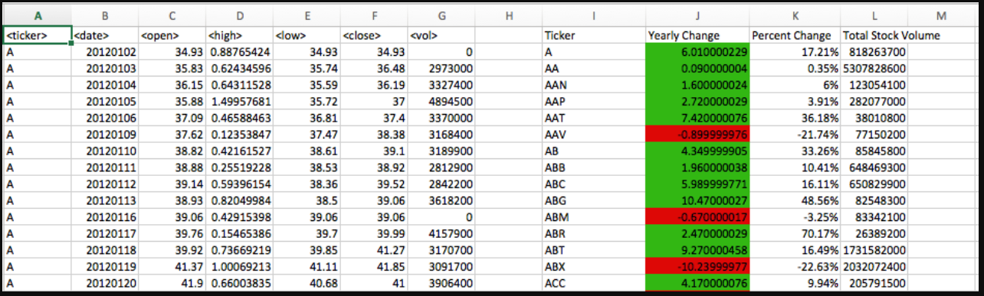

* Create a script that will loop through all the stocks and take the following info.
  + Yearly change from what the stock opened the year at to what the closing price was.
  + The percent change from the what it opened the year at to what it closed.
  + The total Volume of the stock
  + Ticker symbol
* You should also have conditional formatting that will highlight positive change in green and negative change in red.
* The result should look as follows.

**Hard**

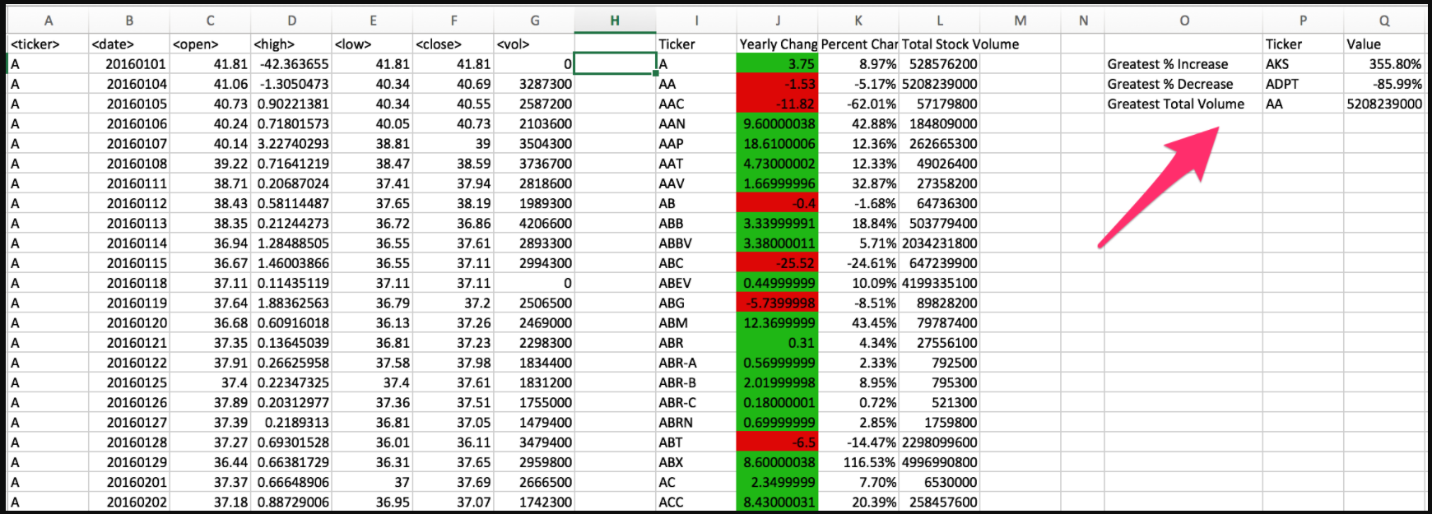

* Your solution will include everything from the moderate challenge.
* Your solution will also be able to locate the stock with the "Greatest % increase", "Greatest % Decrease" and "Greatest total volume".
* Solution will look as follows.

**CHALLENGE**

* Make the appropriate adjustments to your script that will allow it to run on every worksheet just by running it once.
* This can be applied to any of the difficulties.

**Other Considerations**

* Use the sheet alphabetical_testing.xlsx while developing your code. This dataset is smaller and will allow you to test faster.
* Make sure that the script acts the same on each sheet. The joy of VBA is to take the tediousness out of repetitive task and run over and over again with a click of the button.

**Submission**

* Submit a screen shot each year of your results on the Multi Year Stock Data.
* Submit your VBA Scripts as separate files.